Payroll Management System for Information Technology Company

Use-Case Specification: Deleting Department

Version 1.0

Revision History

|  |  |  |  |
| --- | --- | --- | --- |
| **Date** | **Version** | **Description** | **Author** |
| 31/10/2019 | 1.0 | Final Draft | Bùi Tuấn Anh |
|  |  |  |  |
|  |  |  |  |
|  |  |  |  |

Table of Contents

1. Deleting Department 4

1.1 Brief Description 4

1.2 Actor Administrator. 4

2. Flow of Events 4

2.1 Basic Flow 4

3. Special Requirements 5

4. Preconditions 5

5. Postconditions 5

6. Extension Points 5

Use-Case Specification: Deleting Department

# Deleting Department

## Brief Description

This use case defines steps of deleting an existing department from the system.

Administrator can easily delete a department from the system.

## Actor Administrator.

# Flow of Events

## Basic Flow

The system administrator selects the department information to remove. The administrator deletes the database management parameter that holds department information. If an employee is on a department, that department couldn’t be deleted. The administrator displays the updated management parameter value and logs the change.

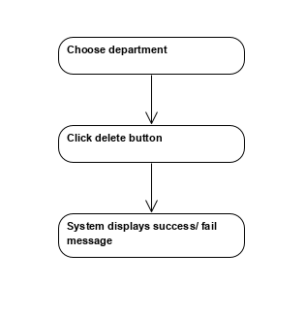



Basic flow of Deleting Department

# Special Requirements

No special requirements.

# Preconditions

Admin logins first then click in Manage Department.

# Postconditions

No postconditions.

# Extension Points

No extension points.